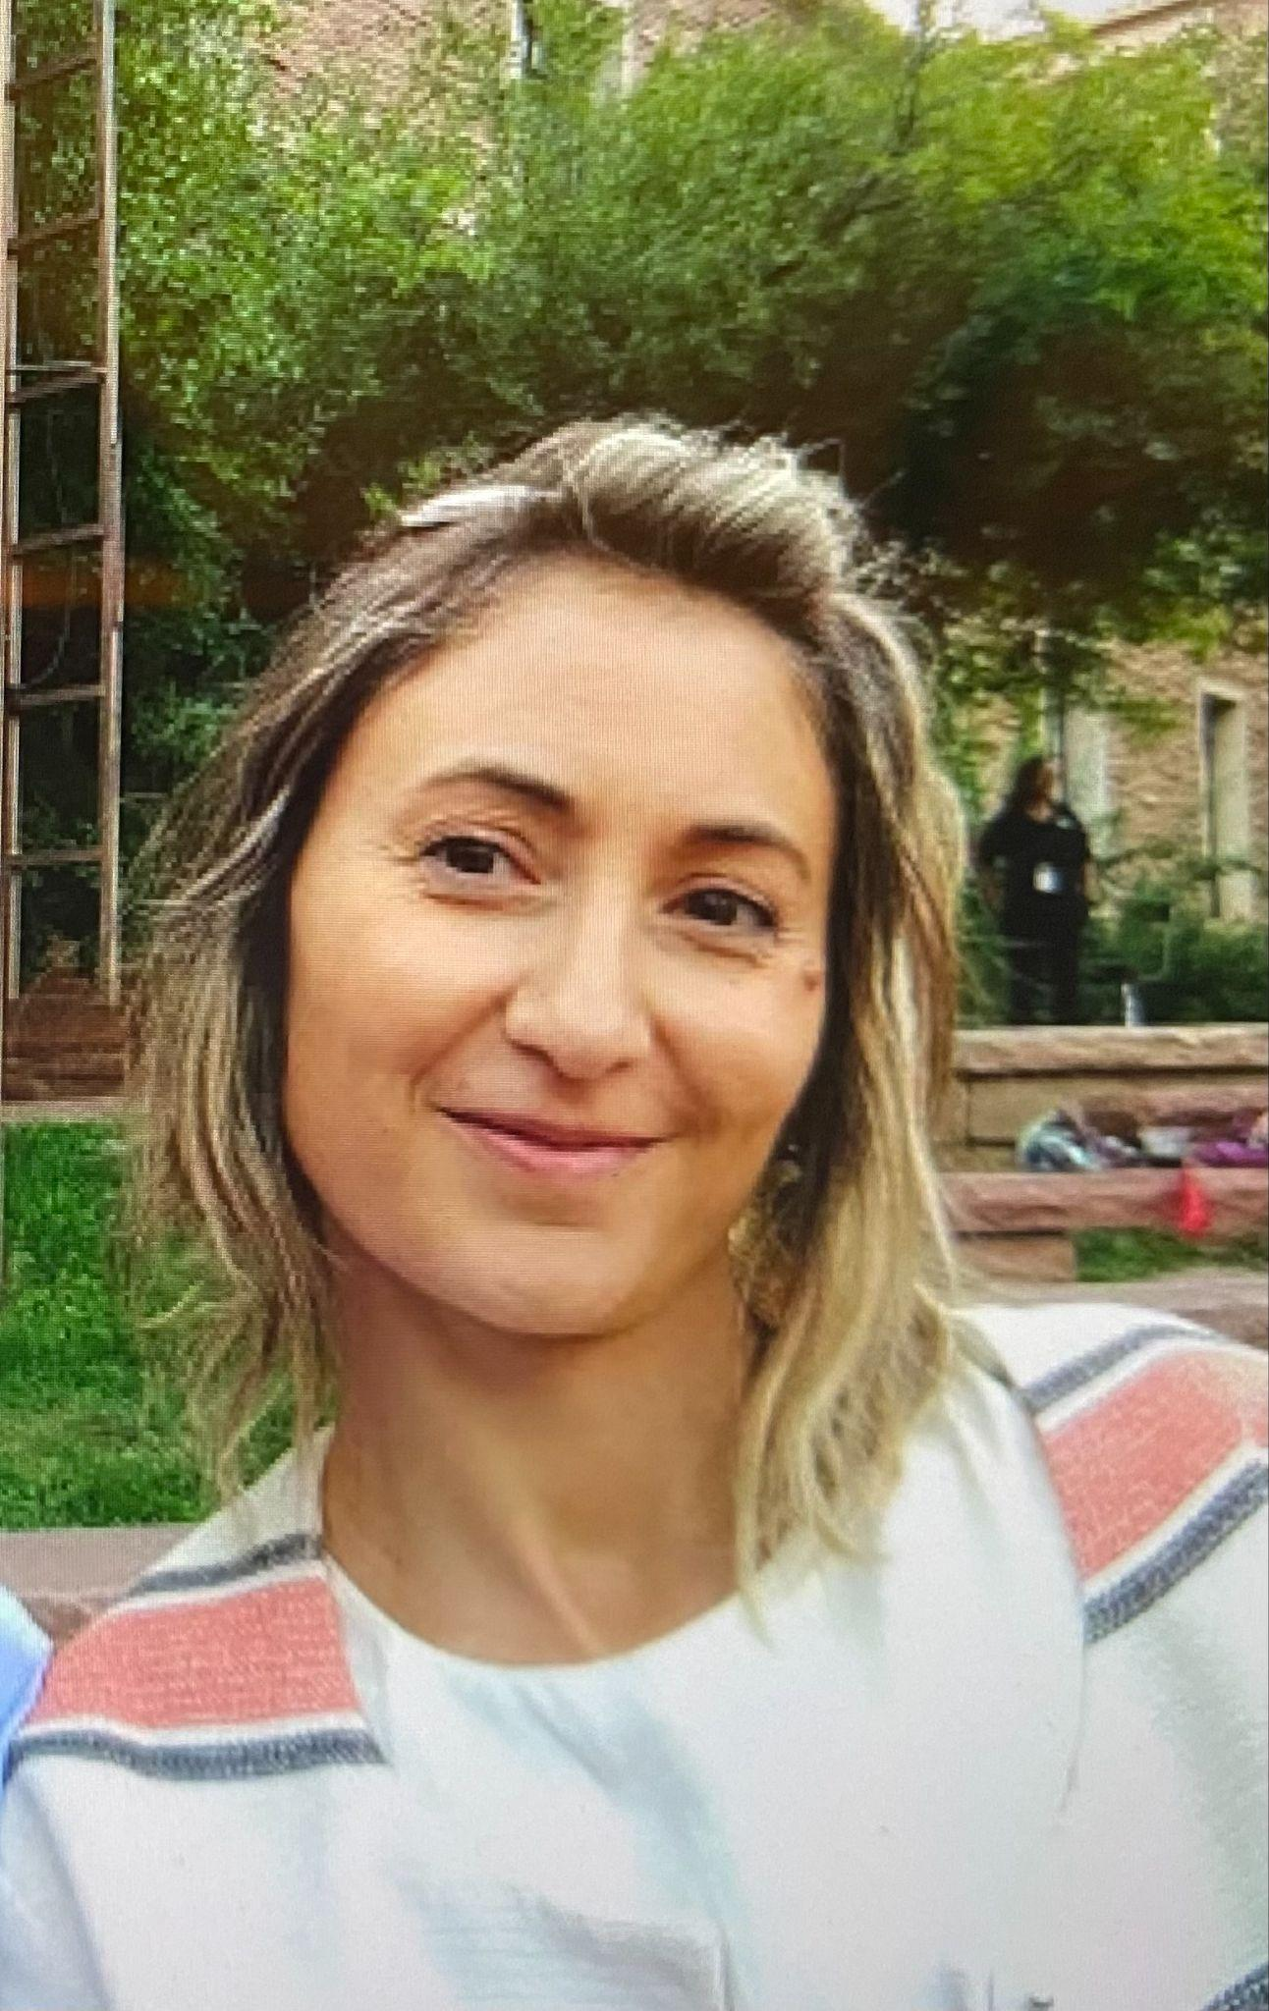
Cecile Givelet holds a Ph-D in Organic Chemistry, and spent five years in Post-Doctoral positions in France, US and Czech Republic.
She became involved with riding therapy for kids with disabilities, and Bead for Life, an organization in Uganda designed to help women living in extreme poverty.
She downsized her life in a 40 pounds backpack to travel the world during more than a year. During her travels, she volunteered at numerous organizations in various countries, i.e., help a mother and her two daughters build adobe houses in Patagonia; volunteered at an orphanage in South India housing and nursing children with tuberculosis and AIDS as well as fundraising; assisted with the education of children in the deep bush of Morogoro, region in Tanzania.
She has been eager to help women and to foster networking for women in need.

